**DEPLOY AN WEBSITE “VIHARA YATRA” ON EC2**

***A Summer Internship Report submitted in partial fulfillment of the***

***requirements for the award of degree of***

**BACHELOR OF TECHNOLOGY**

**In**

**CSE – ARTIFICIAL INTELLIGENCE AND MACHINE LEARNING**

## Submitted by:

## DUNE SANKAR NARAYANA SATHVIK

## 22P31A4279



**CSE – AIML**

**ADITYA ENGINEERING COLLEGE & TECHNOLOGY (A)**

**Approved by AICTE, Permanently affiliated to JNTUK & Accredited by NAAC with ‘A+’ Grade**

**Recognized by UGC under the sections 2(f) and 12(B)of the UGC act 1956**

**Aditya Nagar, ADB Road –Surampalem 533437, E.G. Dist., A.P.,**

**2024-2025.**

**ADITYA ENGINEERING COLLEGE & TECHNOLOGY (A)**

**Approved by AICTE, Permanently Affiliated to JNTUK & Accredited by NAAC with ‘A+’ Grade**

**Recognized by UGC under the sections 2(f) and 12(B) of the UGC act 1956**

**Aditya Nagar, ADB Road - Surampalem – 533437, E.G.Dist., A.P.,**

**CSE – AIML**



**CERTIFICATE**

This is to certify that the Internship report entitled *“***DEPLOY AN WEBINAR “VIHARAYATRA” ON EC2***”*is being submitted by **DUNE SANKAR NARAYAN SATHVIK(22P31A4279)** In partial fulfillment of the requirements for award of the B.Tech degree in CSE- AIML for the academic year 2024-2025.

**Internship Coordinator Head of the Department**

Dr. K. Naga Bhargavi ,M.Tech.,Ph.D. Dr.K.NagaBhargavi,M.Tech.,Ph.D.

Associate Professor Associate Professor

**DECLARATION**

I hereby declare that the Internship entitled **“DEPLOY AN WEBSITE “VIHARA YATRA” ON EC2”**is a genuine report. This work has been submitted to the **ADITYA COLLEGE OF ENGINEERING & TECHNOLOGY (A),** Surampalem, permanently affiliated to **JNTUK, KAKINADA** in partial fulfillment of the **B.Tech** degree**.**

I also hereby declare that this internship report not submitted in full or partial any other university for any degree.

**Dune Sankar Narayana sathvik**

**(22P31A4279)**

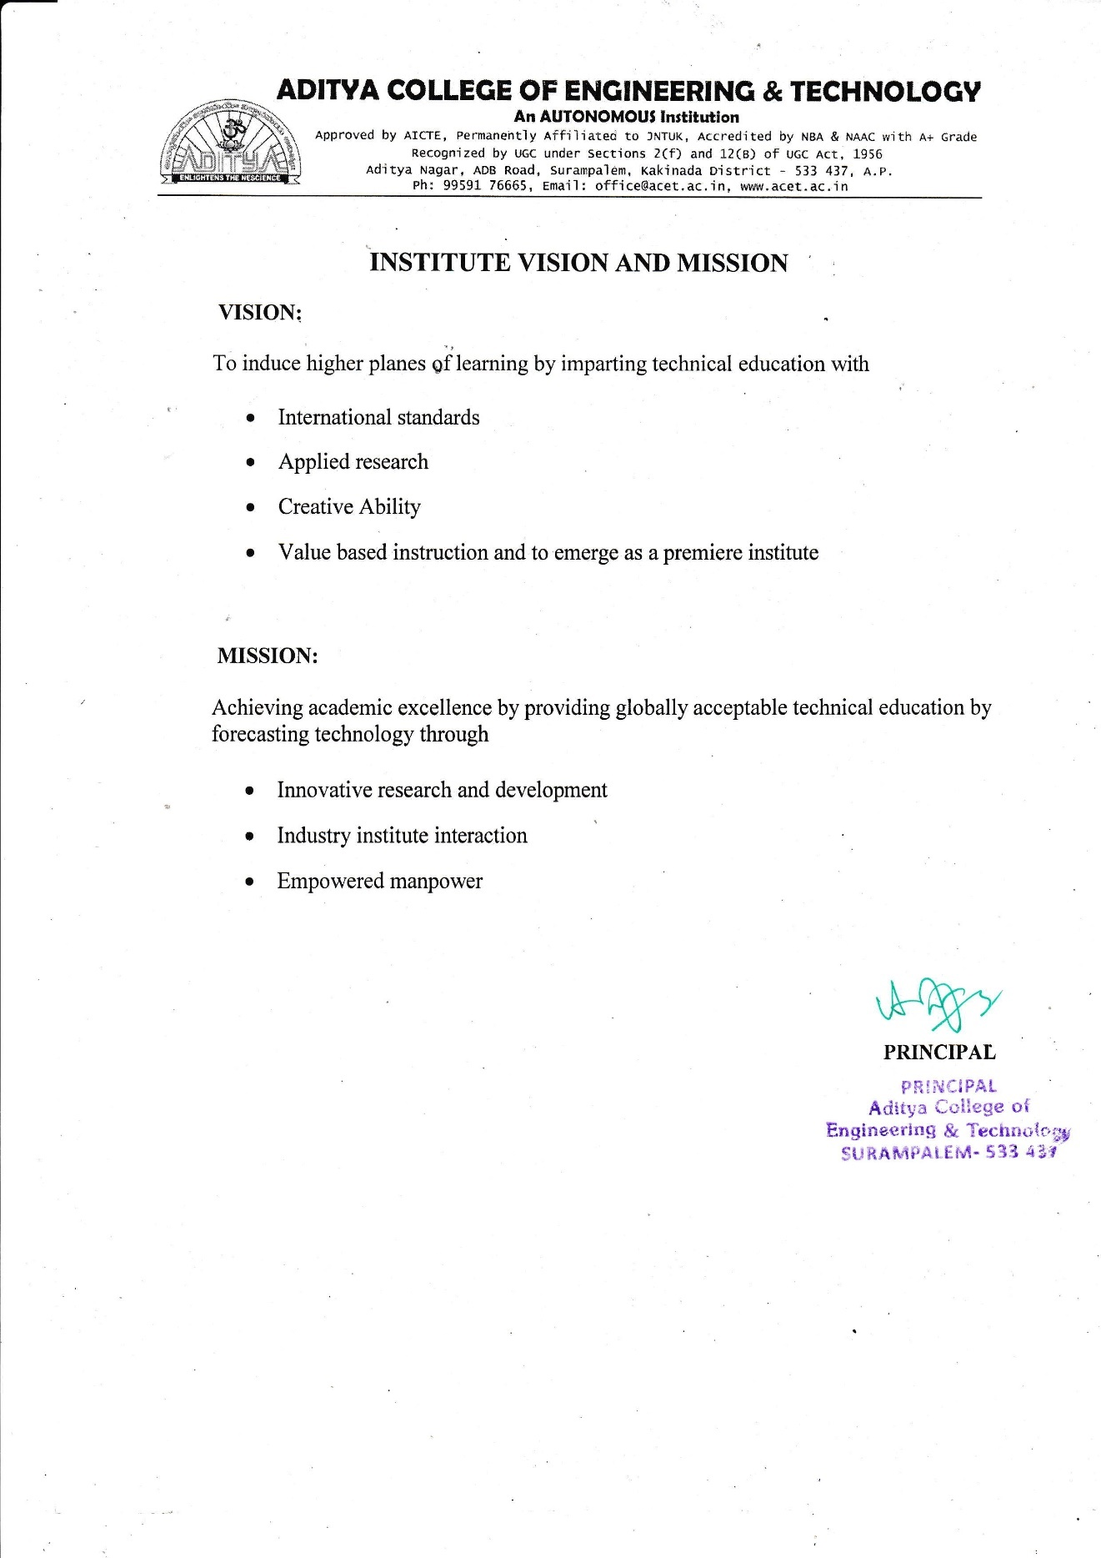

**INTERNSHIP COMPLETION CERTIFICATE**

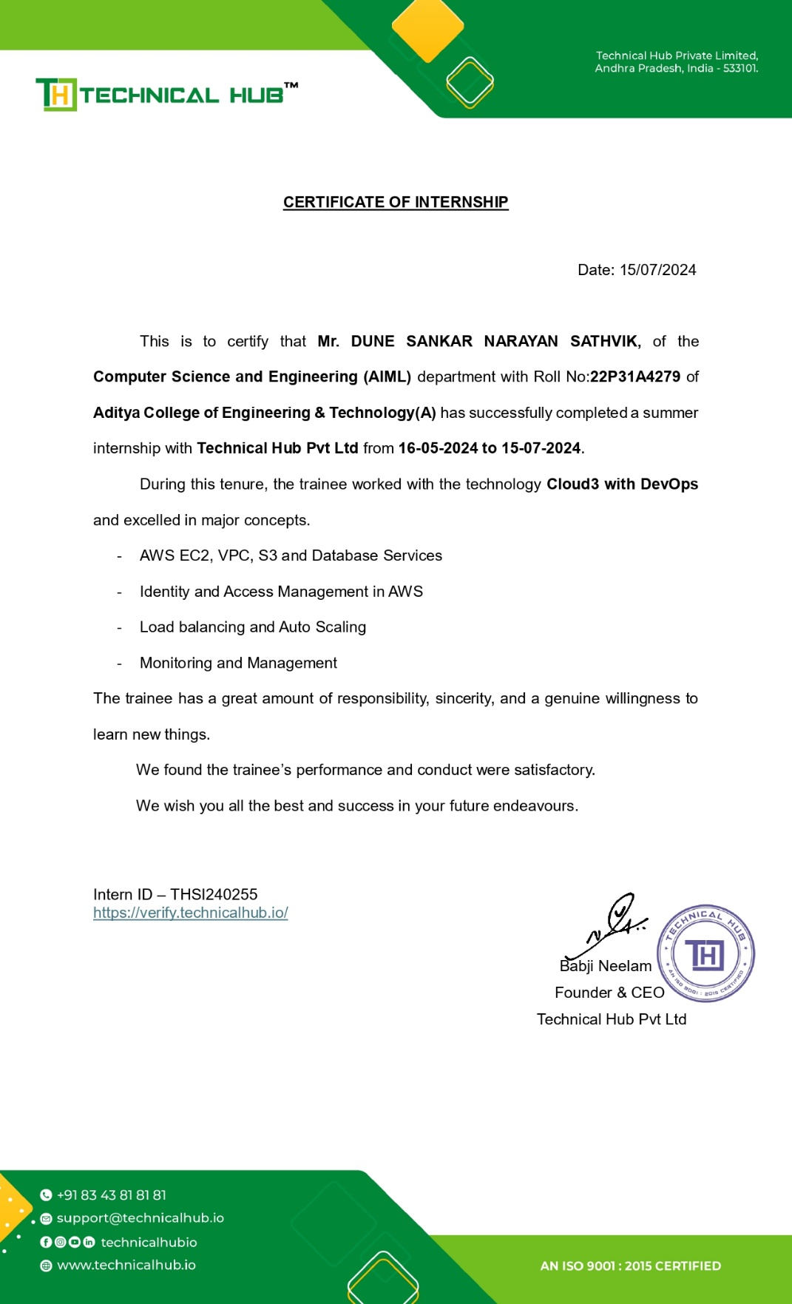

**ACKNOWLEDGEMENT**

I offer my sincere thanks to precious and dynamic Principal, **Dr. A. Ramesh**, **M.Tech,Ph.D**,**Aditya College of Engineering & Technology** **(A)** for his co-operation.

My sincere thanks to Dr.K. Naga Bhargavi, M.Tech, Ph.D, Head of the department of CSE – Artificial Intelligence and Machine Learning for her valuable support.

I express my sincere gratitude to my internship guide, Dr.K. Naga Bhargavi, M.Tech, Ph.D, Head of the department of CSE – Artificial Intelligence and Machine Learning, for her valuable guidance and encouragement which has been helpful in successful completion of this internship.

With immense pleasure I would like to express my deep sense and heart full thanks to the management of Aditya College of Engineering & Technology (A).

**DEPARTMENT VISION AND VISION** 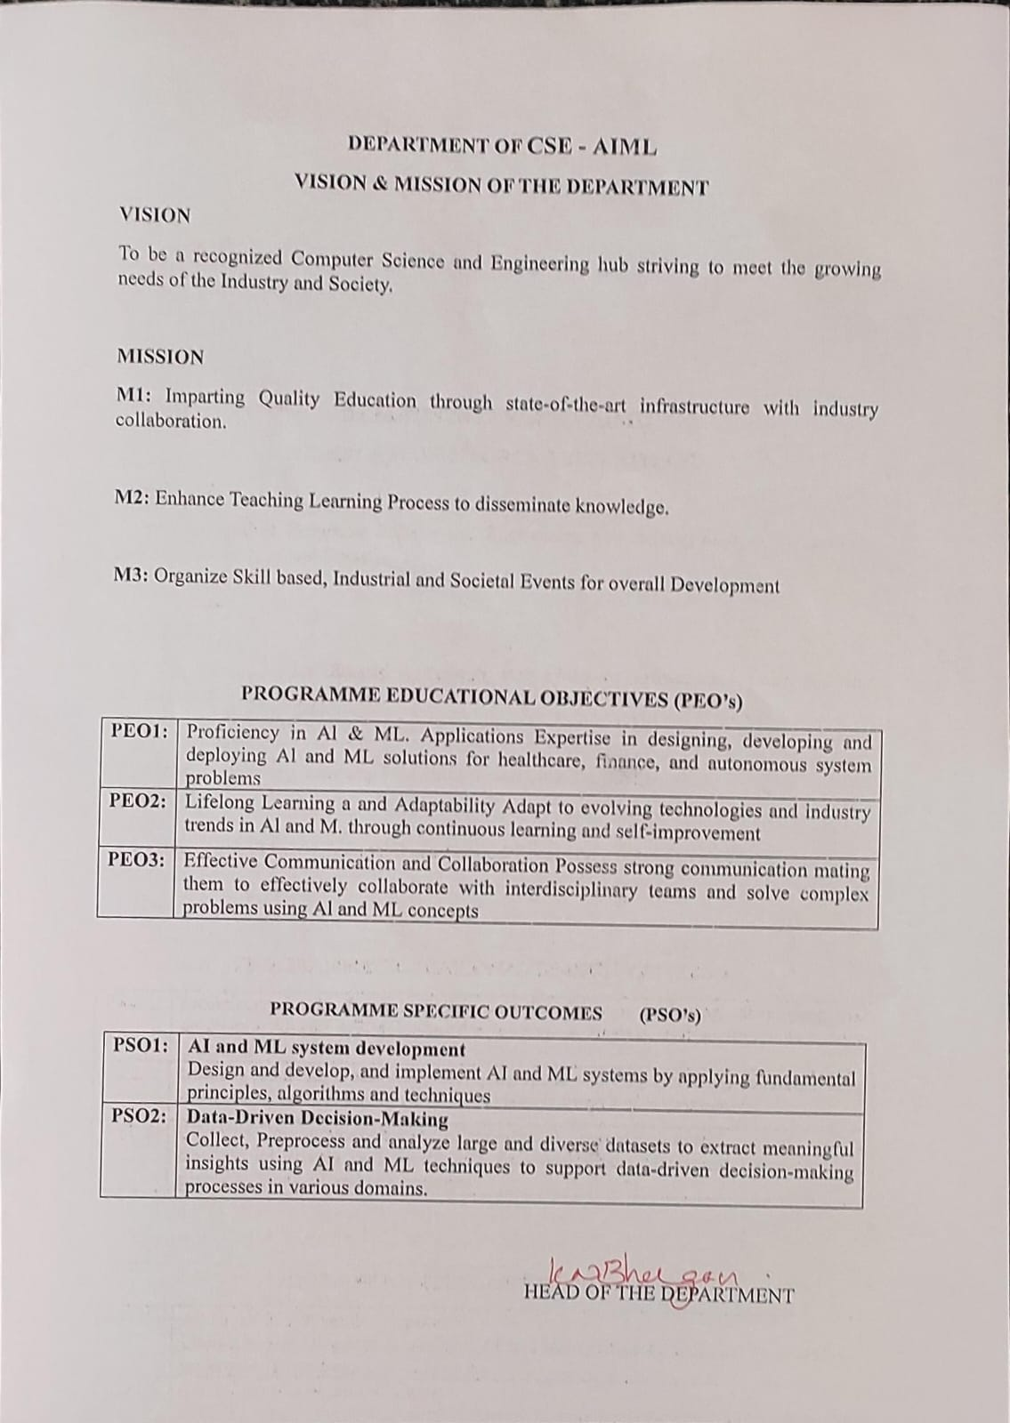

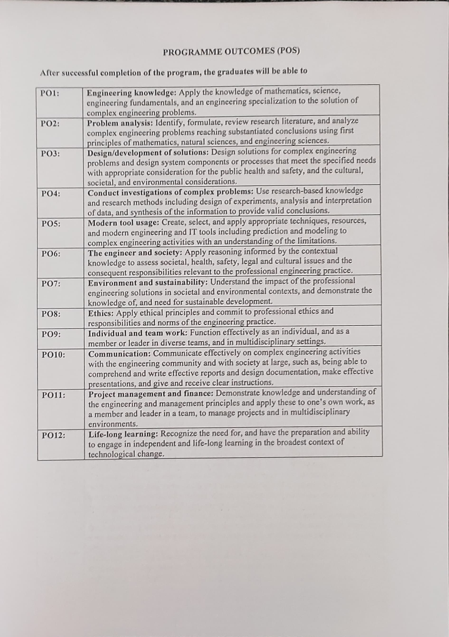

**Learning Objectives / Internship Objectives**

1.Internships are generally thought of to be reserved for college students looking to gain experience in a particular field. However, a wide array of people can benefit from Training Internships in order to receive real world experience and develop their skills.

2.An objective for this position should emphasize the skills you already possess in the area and your interest in learning more

3.Internships are utilized in a number of different career fields, including architecture, engineering, healthcare, economics, advertising and many more.

4.Some internships are used to allow individuals to perform scientific research while others are specifically designed to allow people to gain first-hand experience working.

5.Utilizing internships is a great way to build your resume and develop skills that can be emphasized in your resume for future jobs. When you are applying for a Training Internship, make sure to highlight any special skills or talents that can make you stand apart from the rest of the applicants so that you have an improved chance of landing the position.

**Index**

|  |  |  |  |
| --- | --- | --- | --- |
| **S No.** |  | **Contents** | **Page** |
|  |  |  |  |
| 1. |  | Chapter 1- Executive summary | 9 |
| 2. |  | Chapter 2 -Overview of the Organization | 10-11 |
| 3. |  | Chapter 3- Internship part | 12-14 |
| 4. |  | Weekly Report on Internship Activities |  |
|  | 4.1 | Week 1 Daily Activity and Detail report | 15-16 |
|  | 4.2 | Week 2 Daily Activity and Detail report | 17-18 |
|  | 4.3 | Weak 3 Daily Activity and Detail report | 19-20 |
|  | 4.4 | Week 4 Daily Activity and Detail report | 21-22 |
|  | 4.5 | Week 5 Daily Activity and Detail report | 23-24 |
|  | 4.6 | Week 6 Daily Activity and Detail report | 25-26 |
|  | 4.7 | Week 7 Daily Activity and Detail report | 27-28 |
|  | 4.8 | Week 8 Daily Activity and Detail report | 29-30 |
|  | 4.9 | Week 9 Daily Activity and Detail report | 31-32 |
|  | 4.10 | Week 10 Daily Activity and Detail report | 33-34 |
| 5. |  | Project | 36-47 |
| 6. |  | Outcomes Description | 48-49 |
| 7. |  | Student Self Evaluation of the Short-Term Internship | 50 |
| 8. |  | Evaluation by the Supervisor of the Intern Organization | 51 |
|  |  |  |  |
|  |  |  |  |
|  |  |  |  |
|  |  |  |  |
|  |  |  |  |

# CHAPTER 1: Executive Summary

This report is about my 7 weeks internship program with Technical Hub Private limited. In this comprehensive report, I have discussed about every major aspect of the company which I observed and perceived during my internship program.

During my internship program, I have learned and mainly worked on AWS Development. All the details have been discussed in detail. All the policies and procedures of the company have been discussed in detail.

As them a in purpose of the internship is to learn by working in practical environment and to apply the knowledge acquired during the studies in real world scenario in order to tackle the problems using the knowledge and skill learned during the academic process.

# CHAPTER 2: Overview of the Organization

# A. Introduction of the Organization:

# Aditya's Technical Hub is an innovative initiative established to bridge the gap between engineering education and industry demands. Recognizing the exponential opportunities and dynamic challenges of the 21st century, Technical Hub aims to prepare students for the global job market by providing comprehensive training in various disciplines.

# B. Vision, Mission, and Values of the Organization:

# Vision: To transform engineering education and produce industry-ready professionals who can thrive in a rapidly evolving technological landscape.

# Mission: To equip students with the necessary skills, creativity, and knowledge to advance in their careers and meet the demands of the global industry.

# Values: Innovation, Excellence, Collaboration, Integrity, and Lifelong Learning.

# C. Policy of the Organization, in Relation to the Intern Role:

# Technical Hub places a strong emphasis on hands-on experience and practical

# Learning. Interns are integrated into ongoing projects and are given opportunities to

# develop their skills through real-world applications. The organization provides

# mentorship and resources to ensure that interns gain a comprehensive understanding

# of their -chosen fields.

# D. Organizational Structure:

# The organizational structure of Technical Hub is designed to foster collaboration

# and innovation.

# Key departments include:

# Research and Development

# Training and Development

# Industry Partnerships

# Student Support Services

# E. ROLES AND RESPONSIBILITIES OF THE EMPLOYEES

# Interns at Technical Hub are plaed within the Training and Development department.

# Employees in this department are responsible for Designing and delivering training

# programs .Monitoring student progress and providing feedback.

# Developing new curricula that align with industry needs.Collaborating with industry

# partners to ensure training relevance.

# F. Performance of the Organization:

# Since its inception, Technical Hub has seen remarkable success. The organizationhas

# trained over X,000 students, with a placement rate of Y%. Technical Hub’s partnerships with leading tech companies have expanded its reach and enhanced its market value. The initiative's innovative approach has positioned it as a leader in engineering education reform.

# CHAPTER 3: Internship Part

# Description of the Activities/Responsibilities in the Intern Organization during Internship of AWS Development:

# 1. Working Conditions:

# The internship at Technical Hub provided a supportive and dynamic work environment

# conducive to learning and development. The workspace was equipped with modern

# amenities, promoting a professional yet collaborative atmosphere. Interns were

# encouraged to engage with mentors and peers to enhance their learning experience.

# 2. Weekly Work Schedule:

# The intern followed a structured weekly schedule designed to balance training

# sessions, hands-on projects, and independent learning:

# Monday to Saturday: 9:00 AM - 12:00 PM (special training sessions and workshops)

# Sunday: Day off

# 3. Equipment Used:

# Interns had access to state-of-the-art equipment and software essential for AWS

# development, including:

# - High-performance computers equipped with the latest development tools and software.

# - AWS Management Console and AWS CLI for hands-on cloud computing tasks.

# - Integrated Development Environments (IDEs) such as PyCharm and Visual Studio

# Code for scripting and development.

# -Networking tools for practical exercises in network configuration and troubleshooting.

# 4. Tasks Performed:

# Throughout the internship, the intern engaged in various tasks that provided practical

# experience in AWS development:

# AWS Infrastructure Management: Assisted in the setup, configuration, and

# management of AWS resources, including EC2 instances, S3 buckets, and VPCs.

# Automation with Boto3: Developed and executed Python scripts using Boto3 to

# automate the creation, management, and monitoring of AWS resources.

# Backup and Recovery: Implemented automated backup solutions for EBS volumes

# and tested recovery processes to ensure data integrity and availability.

# Security and Compliance: Worked on securing AWS environments by configuring

# IAM roles, policies, and security groups, and ensuring compliance with best practices.

# Cost Optimization: Analyzed AWS usage and provided recommendations for cost

# optimization, including rightsizing instances and utilizing reserved instances.

# Project Collaboration: Participated in team projects, contributing to planning,

# development and troubleshooting efforts.

# Training Sessions: Attended and facilitated training sessions to enhance

# understanding of AWS services and best practices.

# 5. Skills Acquired:

# The internship provided the intern with a wide range of valuable skills, including:

# Technical Proficiency: Enhanced understanding and hands-on experience with AWS

# services and tools, including EC2, S3, VPC, and IAM.

# Scripting and Automation: Gained proficiency in using Python and Boto3 for

# automating AWS tasks and managing cloud infrastructure.

# Problem-Solving: Developed the ability to troubleshoot and resolve issues related to AWS configurations and performance.

# Security Awareness: Learned to implement and manage security measures to protect cloud resources and ensure compliance.

# Project Management: Improved skills in planning, executing, and managing

# projects in a collaborative environment.

# Communication: Enhanced ability to communicate technical concepts effectively within a team and with mentors.

# Overall, the internship at Technical Hub provided a comprehensive learning experience, blending theoretical knowledge with practical application. The skills and knowledge gained during this period have prepared the intern to meet the demands of the ever-evolving tech industry and excel in AWS development.

# WEEKLY OVERVIEW OF INTERNSHI ACTIVITIES

**ACTIVITY LOG FOR THE FIRST WEEK**

|  |  |  |  |  |
| --- | --- | --- | --- | --- |
| **1stWEEK** | **Date** | **Day** | **Brief Description of Daily Activity** | **Learning Outcomes** |
| 16-05-2024 | Thursday | On-boarding and introduction to company | About company, scope of internship and mentor introduction |
| 17-05-2024 | Friday | Introduction to GitHub and Version Control System | Understanding concept of Version Control System using Git and GitHub |
| 18-05-2024 | Saturday | Introduction to Operating Systems | Understanding the concept of Operating Systems in Servers |

**WEEKLY REPORT**

WEEK – 1 (From Dt 16/05/2024 to Dt 18/05/2024)

**Objective of the Activity Done**: Version Control System & Operating Systems

**Detailed Report**:Since the technology of Cloud Computing requires knowledge of Operating Systems, the activity conducted based on OS concepts understood in Week-1. By doing this activity the I am able to define the benefits of Version Control System and basic and main functionalities of Operating Systems.

.

**ACTIVITY LOG FOR THE SECOND WEEK**

|  |  |  |  |  |
| --- | --- | --- | --- | --- |
| **2nd WEEK** | **Date** | **Day** | **Brief Description of Daily Activity** | **Learning Outcomes** |
| 20-05-2024 | Monday | Working with Different Operating Systems | Explore and work with Windows, Linux and Server versions of Operating Systems |
| 21-05-2024 | Tuesday | Introduction to Client-Server Architecture | Understanding the Client and Server Architecture in real-time environments |
| 22-05-2024 | Wednesday | Different types of Servers | Explore the usage and benefits of various servers such as Web, email, FTP, DHCP, FTP, SSH etc |
| 23-05-2024 | Thursday | Introduction to Networking | Understanding role of Networking and Communication in Datacenters and Cloud |
| 24-05-2024 | Friday | Datacenters and Servers | Exploring the Datacenter environment and infrastructure |
| 25-05-2024 | Saturday | Activity on infrastructure connectivity | Practical knowledge check on topics covered in the 1st & 2nd Week |

**WEEKLY REPORT**

WEEK – 2 (From Dt 20/05/2024 to Dt 25/05/2024)

**Objective of the Activity Done**: Understanding infrastructure connectivity

**Detailed Report:** In this activity, I was able to define and explore different types of servers and the way they connect to each other using IP Networking concepts. By the end of this activity, it is clearly understood that Client-Server architecture works, how the servers in datacenters placed and infrastructure of the cloud environment that is created by connecting multiple datacenters from different locations of the world

**ACTIVITY LOG FOR THE THIRD WEEK**

|  |  |  |  |  |
| --- | --- | --- | --- | --- |
| **3rdWEEK** | **Date** | **Day** | **Brief Description of Daily Activity** | **Learning Outcomes** |
| 27-05-2024 | Monday | Introduction to Cloud Infrastructure | Understanding how the data centers connect in real-time |
| 28-05-2024 | Tuesday | Cloud Computing Models | Explore Cloud computing models as per NIST |
| 29-05-2024 | Wednesday | Cloud Services | Understanding Cloud services as per NIST |
| 30-05-2024 | Thursday | Introduction To Virtualization | Exploring how the traditional computing transitioned to Virtualization |
| 31-05-2024 | Friday | Virtual Severs of Linux | Understanding how the servers created in Virtual Environment |
| 01-06-2024 | Saturday | Activity on Cloud and Virtualization | Practical knowledge check on topics covered until Week-3 |

**WEEKLY REPORT**

WEEK – 3 (From Dt 27/05/2024 to Dt 01/06/2024)

**Objective of the Activity Done**: Cloud and Virtualization

**Detailed Report**: This activity is based on understanding the concepts covered as per Virtualization. By the end of this activity, I was able to explore how the traditional Operating Systems and infrastructure transitioned to virtual environment. It is also understood that virtualization is the pillar of cloud computing concept and how the cloud is built using the various concepts of virtualization.

The infrastructure virtualization is the core concept behind cloud computing that give the customers to manage their resources flexibly considering High Availability, Scalability, Security and Reliability concepts of various server types and cloud services.

**ACTIVITY LOG FOR THE FOURTH WEEK**

|  |  |  |  |  |
| --- | --- | --- | --- | --- |
| **4thWEEK** | **Date** | **Day** | **Brief Description of Daily Activity** | **Learning Outcomes** |
| 03-06-2024 | Monday | Introduction to Linux OS | Understanding why Linux is everywhere |
| 04-06-2024 | Tuesday | Holiday | Holiday (AP Election Results) |
| 05-06-2024 | Wednesday | Linux command syntax and basic commands | Understand the usage of Linux command syntax |
| 06-06-2024 | Thursday | Linux User and Groups | Explore different types of users and groups in Linux |
| 07-06-2024 | Friday | Basic file and directory permission in Linux | Exploring how the permissions work for file, directories, users & Groups |
| 08-06-2024 | Saturday | Activity on Linux Operating System | Practical knowledge check on topics covered until Week-4 |

**WEEKLY REPORT**

WEEK – 4 (From Dt 03/06/2024 to Dt 08/06/2024)

**Objective of the Activity Done**: Working with Linux Operating system

**Detailed Report:** Linux Operating System is considered as a one of the best Open-Source platforms deployed on most the server applications used today. Because of the flexibility of using the applications with integrated security options in Linux, this OS became a widely used platform preferred by major application providers in the world.

By the end of this activity I explore the command syntax of Linux Operating System, OS file system and hierarchy, working with files and directories, applying file and directory level permissions, creating users and working with different types of editors etc.

**ACTIVITY LOG FOR THE FIFTH WEEK**

|  |  |  |  |  |
| --- | --- | --- | --- | --- |
| **5thWEEK** | **Date** | **Day** | **Brief Description of Daily Activity** | **Learning Outcomes** |
| 10-06-2024 | Monday | Introduction to AWS Services and Service Categories | Understanding AWS offered services and its categories |
| 11-06-2024 | Tuesday | Understanding AWS Management Console | Explore AWS Management console using sandbox |
| 12-06-2024 | Wednesday | AWS Regions and Availability Zones | Explore and Switch between AWS Regions |
| 13-06-2024 | Thursday | Introduction to AWS Compute Services | Understanding AWS Compute service EC2 and related components |
| 14-06-2024 | Friday | Working with EC2 Service | Exploring various launching options of EC2 |
| 15-06-2024 | Saturday | Activity on AWS Management Console and EC2 Service | Practical knowledge check on topics covered until Week-5 |

**WEEKLY REPORT**

WEEK – 5 (From Dt 10/06/2024 to Dt 15/06/2024)

**Objective of the Activity Done**: AWS Management console and EC2 Service

**Detailed Report:** Since we understood the cloud infrastructure, Operating Systems, Server-Client and Linux OS concepts, we tried launching the server in AWS Cloud named EC2 instance using AWS Management console. By the end of this activity, I am able to explore and understand how the virtual server can be launched using AWS Cloud and connect to it using various connectivity methods.

It is clear that how the EC2 instances can be connected to on-premises to copy and migrate the data from on-premises servers to cloud instances.

**ACTIVITY LOG FOR THE SIXTH WEEK**

|  |  |  |  |  |
| --- | --- | --- | --- | --- |
| **6thWEEK** | **Date** | **Day** | **Brief Description of Daily Activity** | **Learning Outcomes** |
| 17-06-2024 | Monday | Holiday | Holiday (Bakrid) |
| 18-06-2024 | Tuesday | Web application deployment on Windows Server | Deploying sample web application on Windows EC2 server |
| 19-06-2024 | Wednesday | EC2Web application deployment on Linux Server | Deploying sample web application on Ubuntu and Amazon EC2 server |
| 20-06-2024 | Thursday | EC2 Managing options for EC2 instance | EC2 managing options such as stop, start, terminate etc. |
| 21-06-2024 | Friday | Ways of connecting to Linux EC2 instances using SSH. Sharing data between local and cloud EC2 instances | Exploring different ways of securely connecting to EC2 instance |
| 22-06-2024 | Saturday | Activity on web application deployment using EC2 compute service | Practical knowledge check on topics covered until Week-6 |

**WEEKLY REPORT**

WEEK – 6 (From Dt 17/06/2024 to Dt 22/06/2024)

**Objective of the Activity Done**: Web application deployment in cloud servers

**Detailed Report:** Deploying the applications in cloud is an easy and flexible task after understanding the EC2 instance concepts. I obtain practical knowledge on how the applications will be deployed in cloud instances and can be accessed using security groups created.

In this activity, I launched Linux and Windows server instances and deployed various kinds of web applications. Used the security groups to allow and deny access to some of the ports and IP Addresses.

**ACTIVITY LOG FOR THE SEVENTH WEEK**

|  |  |  |  |  |
| --- | --- | --- | --- | --- |
| **7thWEEK** | **Date** | **Day** | **Brief Description of Daily Activity** | **Learning Outcomes** |
| 24-06-2024 | Monday | Introduction to Storage technologies | Explore and understand various storage technologies |
| 25-06-2024 | Tuesday | Block vs Object Storage serives | Understanding difference between Block and Object storage |
| 26-06-2024 | Wednesday | Working with AWS S3 | Understanding S3 buckets and objects |
| 27-06-2024 | Thursday | Volumes and Snapshots using AWS Elastic Block Storage | Exploring EBS volume and snapshot concepts |
| 28-06-2024 | Friday | Working with EBS Snapshots | Create, Delete and reconnect EBS volume snapshots |
| 29-06-2024 | Saturday | Activity on AWS Object and Block Storage | Practical knowledge check on topics covered until Week-7 |

**WEEKLY REPORT**

WEEK – 7 (From Dt 24/06/2024 to Dt 29/06/2024)

**Objective of the Activity Done**: Working with AWS Object and block storage services

**Detailed Report**: Data backup and recovery is vital process in server management. Backing up the data and volumes of servers in proper scheduling makes the task of Disaster Recovery an easier one. In this activity, explored on AWS Block storage service that allows the customer to take snapshots of volumes easily for backup purposes.

Also, deployed the static website using AWS S3 object storage service that is an unlimited storage service offered.

**ACTIVITY LOG FOR THE EIGHTH WEEK**

|  |  |  |  |  |
| --- | --- | --- | --- | --- |
| **8thWEEK** | **Date** | **Day** | **Brief Description of Daily Activity** | **Learning Outcomes** |
| 01-07-2024 | Monday | Introduction to AWS Networking Service | Understanding AWS VPC Service |
| 02-07-2024 | Tuesday | AWS Virtual Private Cloud and its components | Explore Subnet and Routing table components of AWS VPC |
| 03-07-2024 | Wednesday | IPv4 Addressing and Subnetting | Understanding IPv4 vs IPv6. Subnetting IPv4 Addressing |
| 04-07-2024 | Thursday | Launching and Connecting resources in AWS VPC | Exploring AWS VPC by launching and connecting resources in it |
| 05-07-2024 | Friday | Web deployment using AWS Elastic Beanstalk | Understanding serverless deployment using AWS Elastic Beanstalk |
| 06-07-2024 | Saturday | Activity on AWS VPC and Elastic Beanstalk | Practical knowledge check on topics covered until Week-8 |

**WEEKLY REPORT**

WEEK – 8 (From Dt 01/07/2024 to Dt 06/07/2024)

**Objective of the Activity Done**: AWS VPC and Elastic Beanstalk

**Detailed Report**: Deployed the sample web application using serverless technology. Elastic Beanstalk is the serverless service offered by AWS to deploy web applications on the go without focusing much on virtual infrastructure. This service comes under the category of Platform as a Service (PaaS).

Created an isolated network in cloud that is Virtual Private Cloud, as network service offered by AWS to create networks within regions. Launched the ec2 server resources in VPC and used concepts of Subnet, Internet Gateway, Routing Tables etc to connect successfully to these services.

**ACTIVITY LOG FOR THE NINTH WEEK**

|  |  |  |  |  |
| --- | --- | --- | --- | --- |
| **9thWEEK** | **Date** | **Day** | **Brief Description of Daily Activity** | **Learning Outcomes** |
| 08-07-2024 | Monday | Introduction to Development on AWS | Exploring development services in AWS |
| 09-07-2024 | Tuesday | Working with AWS Cloud Shell, AWS CLI & AWS Cloud9 IDE | Understanding CLI access and AWS Cloud9 IDE environments |
| 10-07-2024 | Wednesday | Static website deployment in AWS S3 using Python for AWS SDK (boto3) | Understanding how to deploy the AWS services using boto3 |
| 11-07-2024 | Thursday | Secure access to cloud resources using AWS Identity and Access Management | Understanding how the access to cloud resources can be controlled using AWS IAM |
| 12-07-2024 | Friday | Working with AWS NoSQL services and AWS DynamoDB | Differentiate between SQL and NoSQL databases and explore on NoSQL based AWS DynamoDB service |
| 13-07-2024 | Saturday | Project Deployment | Hand-on project with use case applying knowledge of all topics covered until Week-9 |

**WEEKLY REPORT**

WEEK – 9 (From Dt 08/07/2024 to Dt 13/07/2024)

**Objective of the Activity Done**: Working with AWS Development Services

**Detailed Report**: After going through the development services available in AWS, able to work with then by deploying and creating web applications and databases in cloud.

Worked with AWS SDK, AWS Cloud9, AWS CLI and AWS Code Whisperer to deploy the applications and database services. Used AWS SDK for Python that is also known as boto3 in AWS to deploy the static website in s3.

Configured the users and groups to access resources securely using IAM service. Used the NoSQL based AWS DynamoDB service to create tables and items related to web applications.

**ACTIVITY LOG FOR THE TENTH WEEK**

|  |  |  |  |  |
| --- | --- | --- | --- | --- |
| **10thWEEK 9thWEEK** | **Date** | **Day** | **Brief Description of Daily Activity** | **Learning Outcomes** |
| 15-07-2024 | Monday | Project Deployment | Hand-on project with use case applying knowledge of all topics covered until Week-9 |

**WEEKLY REPORT**

WEEK – 10 (From Dt 13/07/2024 to Dt 15/07/2024)

**Objective of the Activity Done**: Project Deployment

**Detailed Report:**

**Project Title:** DEPLOY AN WEBSITE “VIHARA YATRA” ON EC2

**Objective:** Set up and deploy a “Vihara Yatra” website on an Amazon EC2 instance

1. **Requirement Analysis:**
   * Determine the specific requirements for the “Vihara Yatra” website, including functionalities and technologies.
2. **Environment Setup:**
   * Provision an Amazon EC2 instance with an appropriate configuration based on anticipated traffic and resource needs.
   * Configure the EC2 instance with the necessary operating system and software stack
3. **Website Deployment:**
   * Install and configure the vihara yatra travels platform on the EC2 instance.
   * Upload and configure the website files, including themes, plugins, and extensions.
4. **Security Configuration:**
   * Implement security measures such as firewalls, SSL certificates, and access controls to protect the website and user data.
   * Regularly update and patch software to address vulnerabilities.
5. **Testing:**
   * Conduct thorough testing of the website to ensure all functionalities work as intended.
   * Perform load testing to assess the website's performance under various traffic conditions.
6. **Launch and Monitoring:**
   * Launch the travels(vihara yatra) website and monitor its performance using AWS tools and third-party services.
   * Set up automated scaling and load balancing if needed to handle varying traffic loads.
7. **Maintenance and Support:**
   * Provide ongoing maintenance, including software updates, security patches, and performance optimizations.
   * Offer technical support to address any issues or improvements.

**Deliverables:**

* A travels website deployed on Amazon EC2.
* Documentation including setup procedures, configurations, and security measures.
* Testing reports and performance assessments.

**CHAPTER 5: PROJECT**

**TITLE: DEPLOY AN WEBSITE “VIHARA YATRA” ON EC2.**

* **Introduction**

This guide provides step-by-step instructions for setting up a Virtual Private Cloud (VPC) in Amazon Web Services (AWS) and launching an EC2 instance within that VPC. A VPC is a virtual network dedicated to your AWS account, allowing you to isolate your resources and control network settings.

* **Creating a Virtual Private Cloud (VPC)**

1.Sign in to AWS Management Console

2.Go to the [AWS Management Console](https://aws.amazon.com/console/).

3.Log in with your AWS credentials.

* Access the VPC Dashboard

1.In the AWS Management Console, navigate to **Services**.

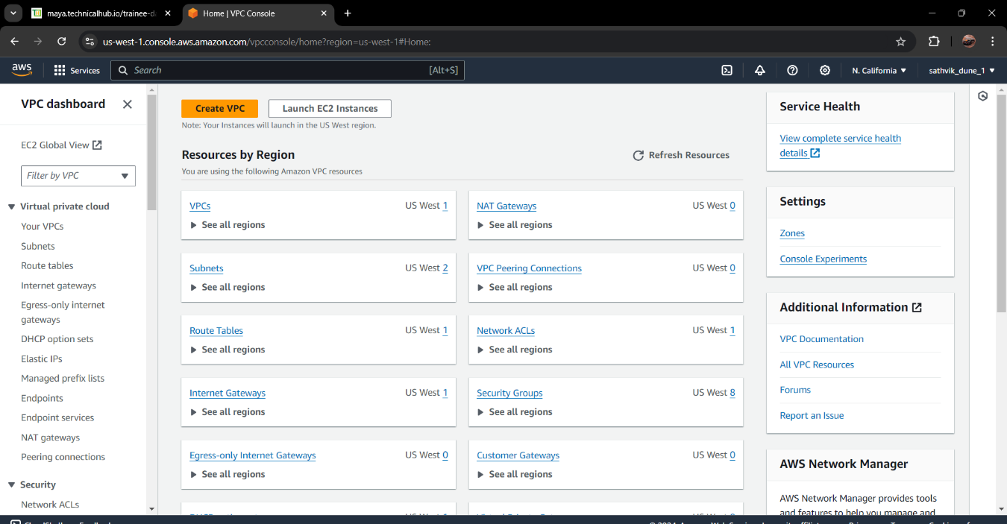

* Create a VPC and Configure VPC Settings
* 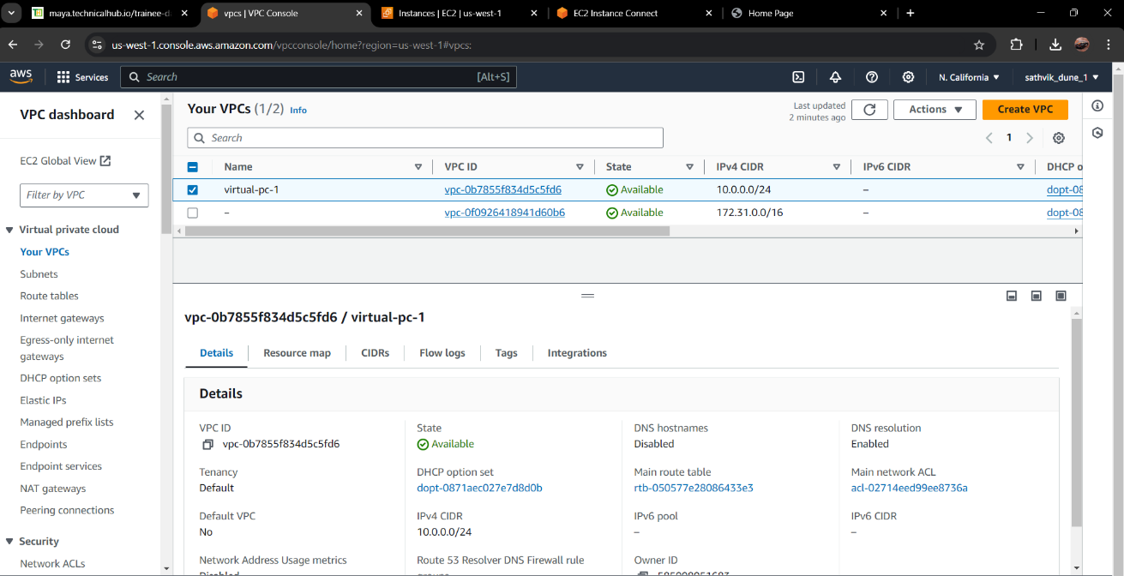

1.Click on Create VPC.

2.Name tag: Enter a name for your VPC

3.IPv4 CIDR block: Specify the IPv4 CIDR block. This defines the IP address range for your VPC.

4.IPv6 CIDR block: Choose an IPv6 CIDR block if needed.

5.Tenancy: Select Default for standard usage or Dedicated if you need a dedicated instance hardware.

6.Click Create VPC.

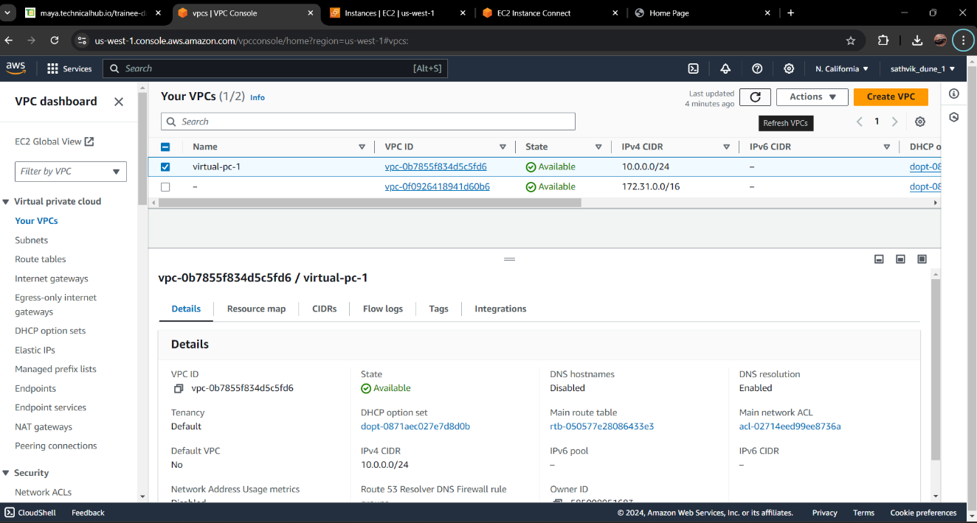

* Create Subnets

In the VPC Dashboard, select Subnets from the left-hand menu.

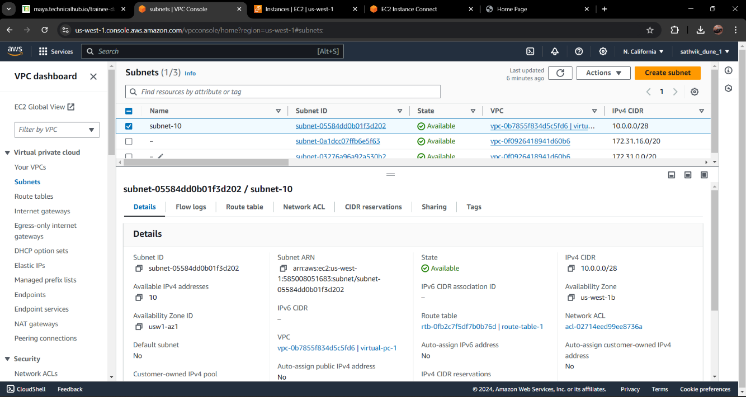

Click Create subnet

* Configure Subnet Settings:

1.Name tag: Enter a name for the subnet.

2.VPC: Select the VPC you created.

3.Availability Zone: Choose an Availability Zone.

4.IPv4 CIDR block: Specify a CIDR block for the subnet. Click Create subnet.

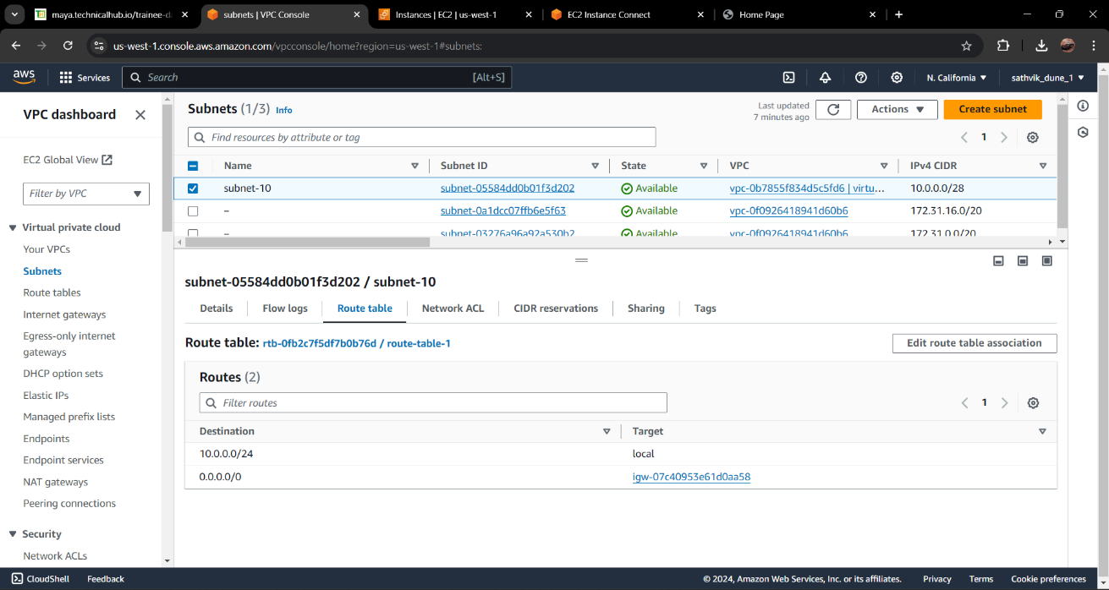

* Create an Internet Gateway

Click Create internet gateway.

Configure Settings:

1.Name tag: Enter a name for the Internet Gateway.

2.Click Create internet gateway.

3.After creating the Internet Gateway, select it from the list and click Actions,

then Attach to VPC.

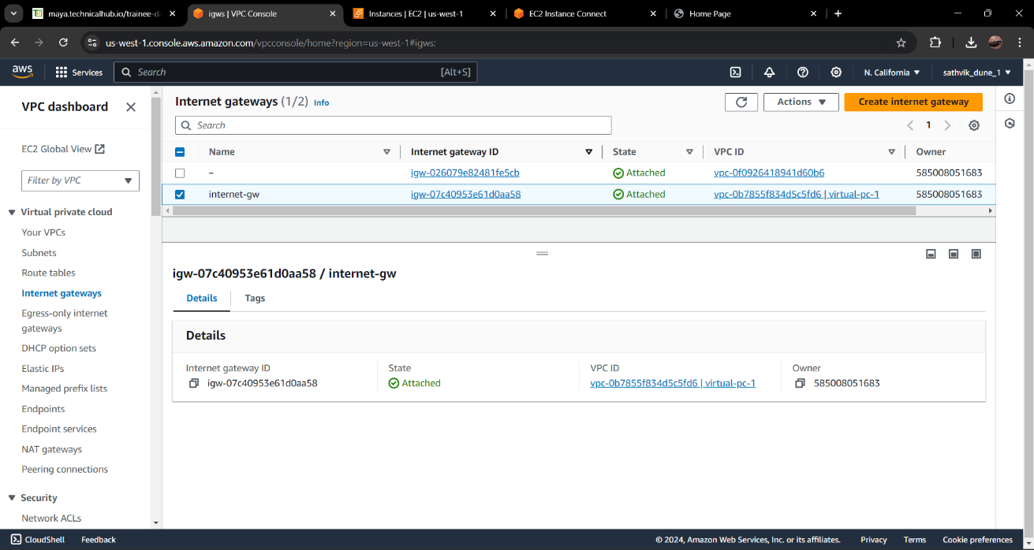

4. Choose the VPC you created and click Attach Internet Gateway.

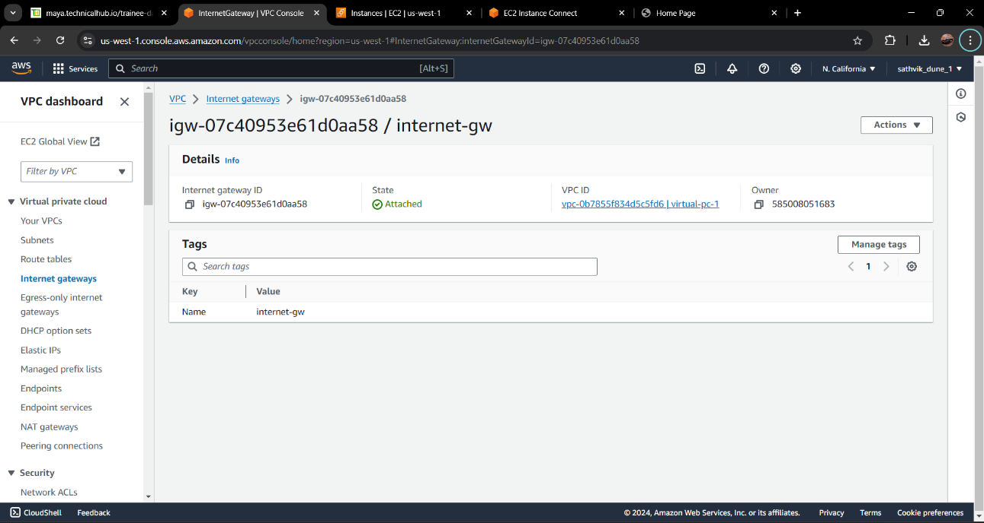

* Create Route Table and Attach to subnets.

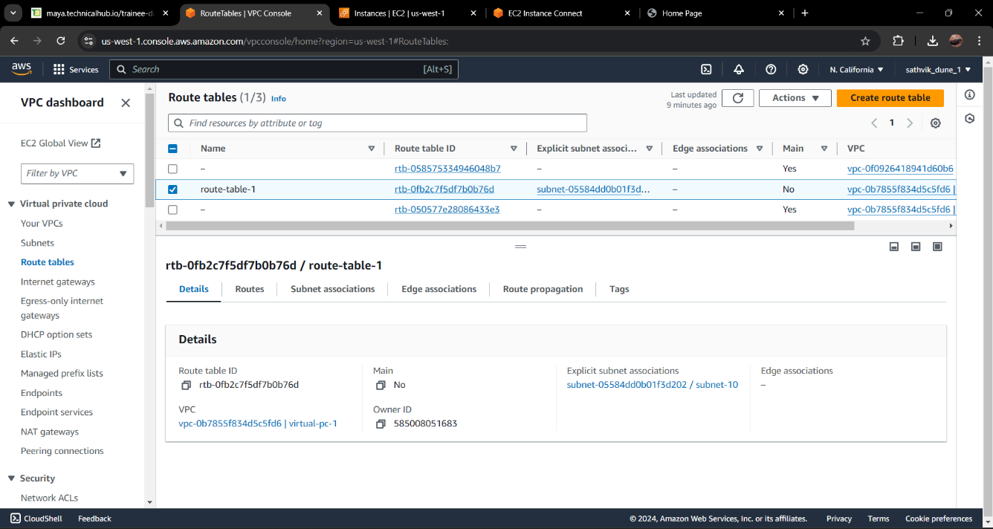

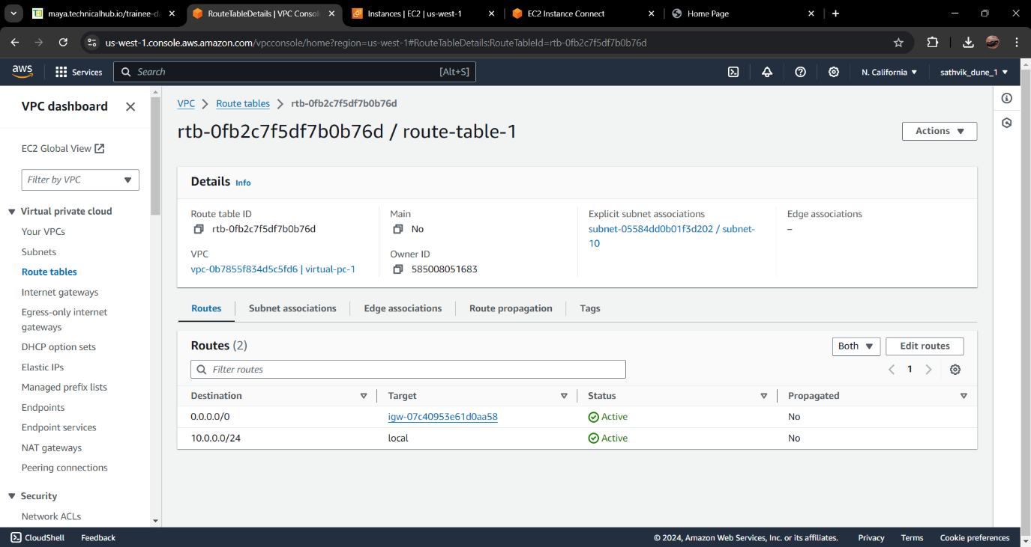

1.Choose the main route table associated with your VPC (or create a new one if necessary).

2.Click Edit routes and then Add route.

3.Destination: Enter 0.0.0.0/0 to allow all outbound traffic.

4 Target: Select the Internet Gateway you created.

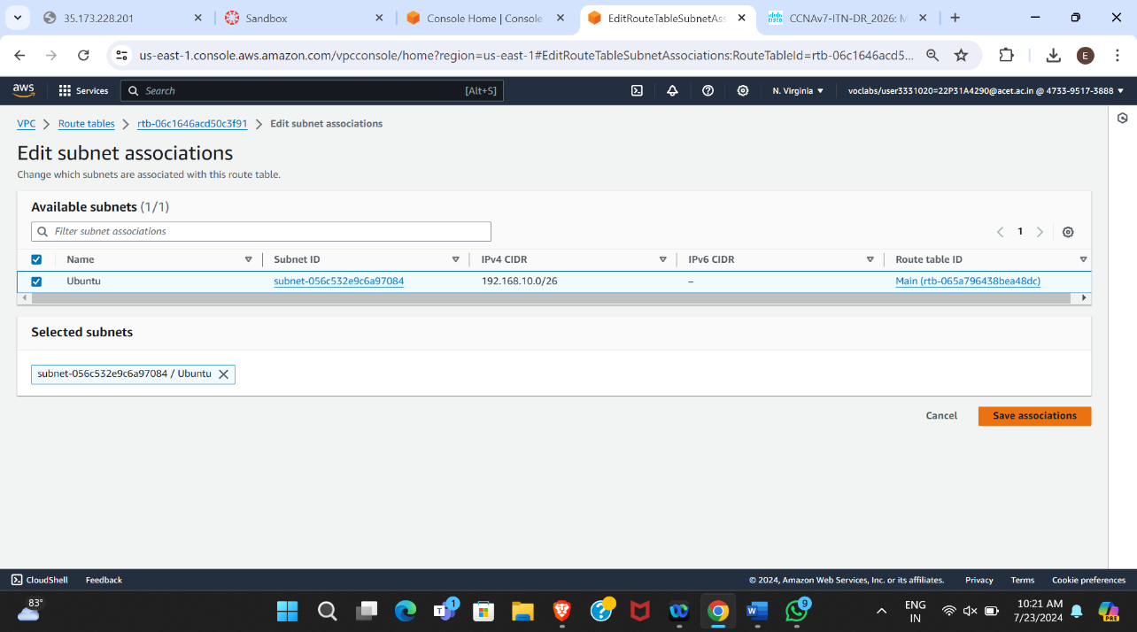 5.Click Save routes.

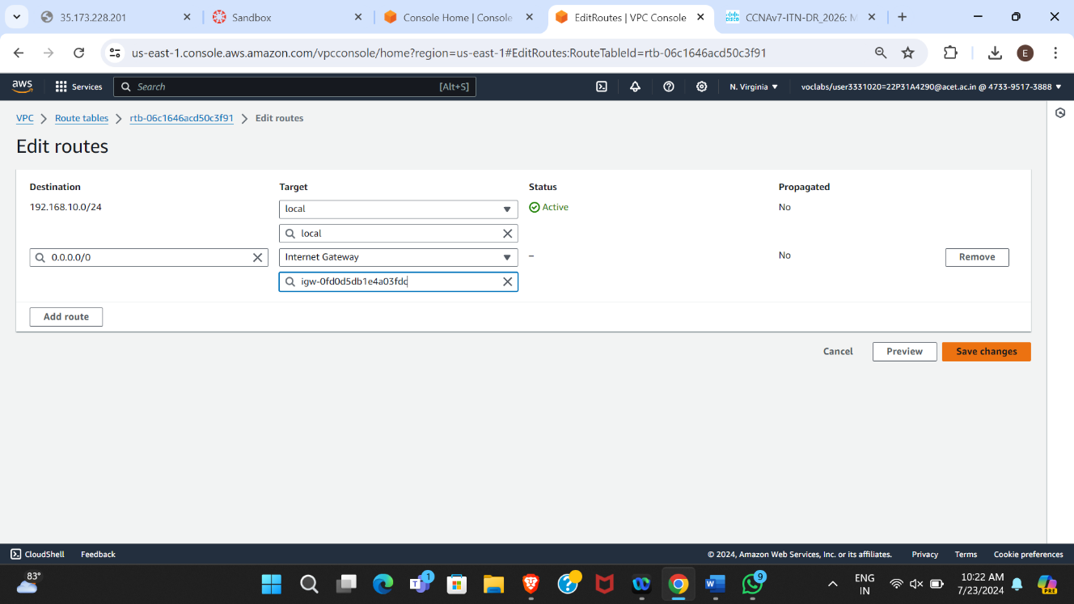

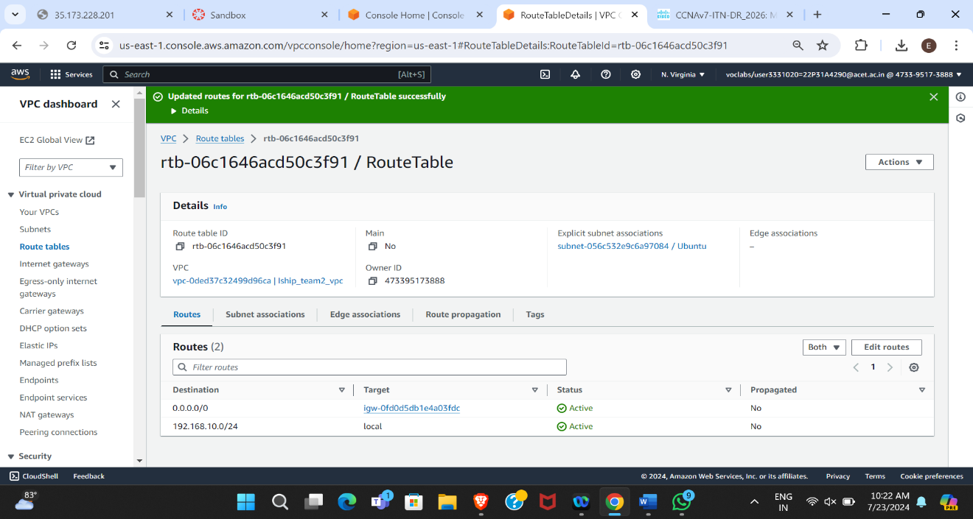

* **Launch an EC2 Instance in the VPC**
* Access the EC2 Dashboard
* In the AWS Management Console, navigate to Services.
* Under Compute, select EC2.
* Launch an EC2 Instance
* Click Launch Instance.

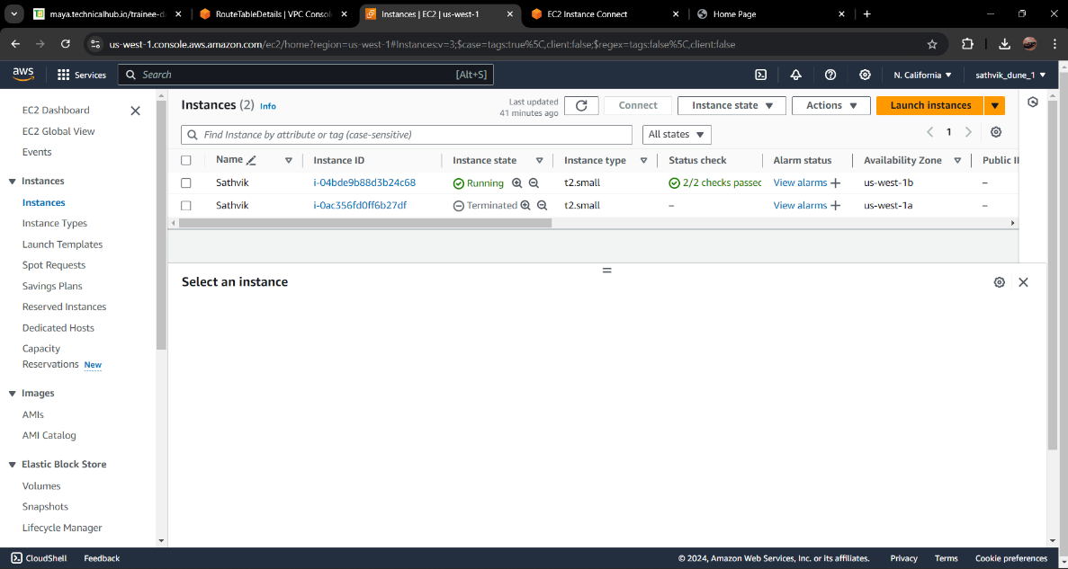

* Choose an Amazon Machine Image (AMI):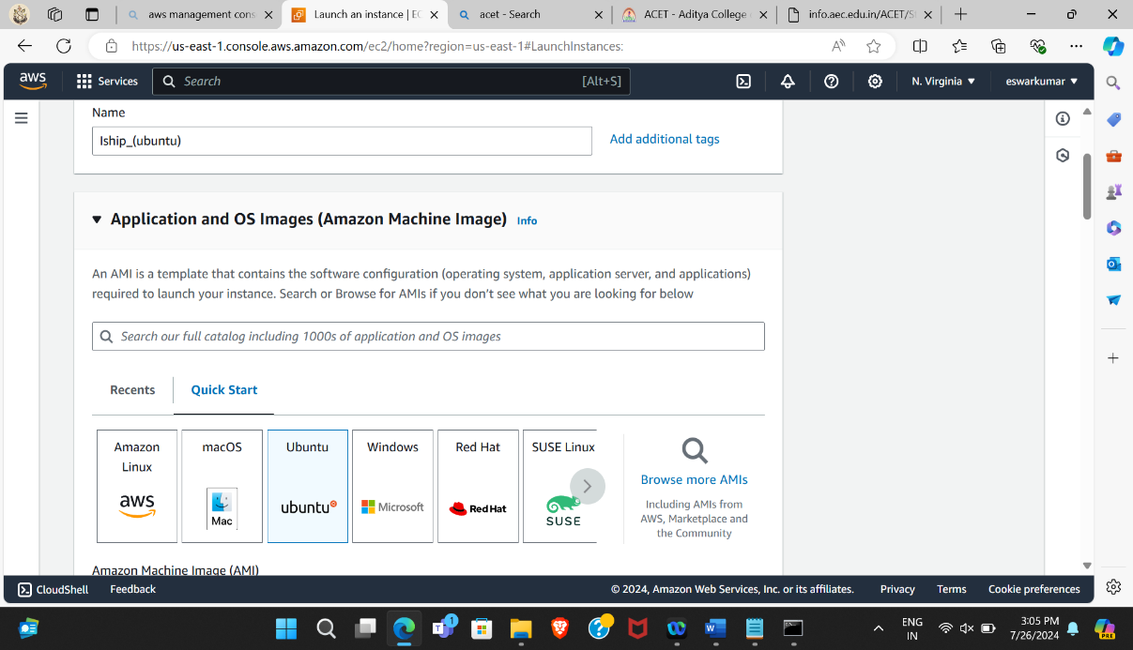Select an AMI that suits your needs

* Network: Select the VPC you created.
* Subnet: Choose the subnet within the VPC.
* Auto-assign Public IP: Choose Enable if you need the instance to be accessible from the internet.
* 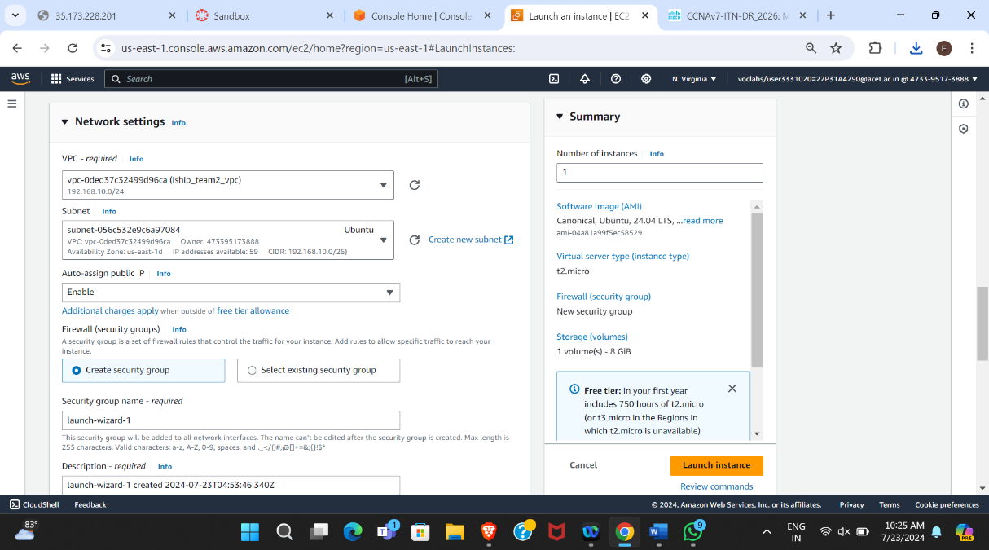Configure other settings as needed

* Configure Security Group:

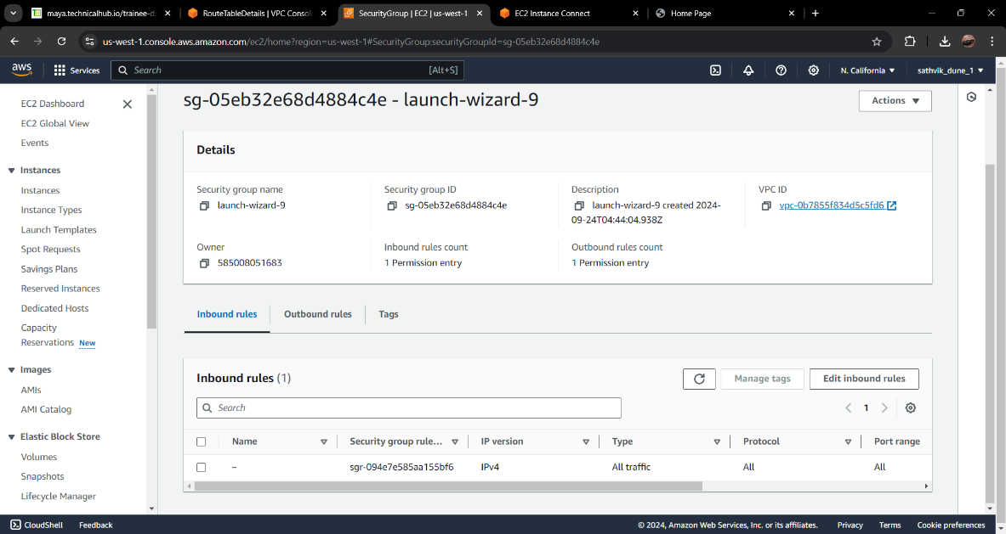

* Launch Instance

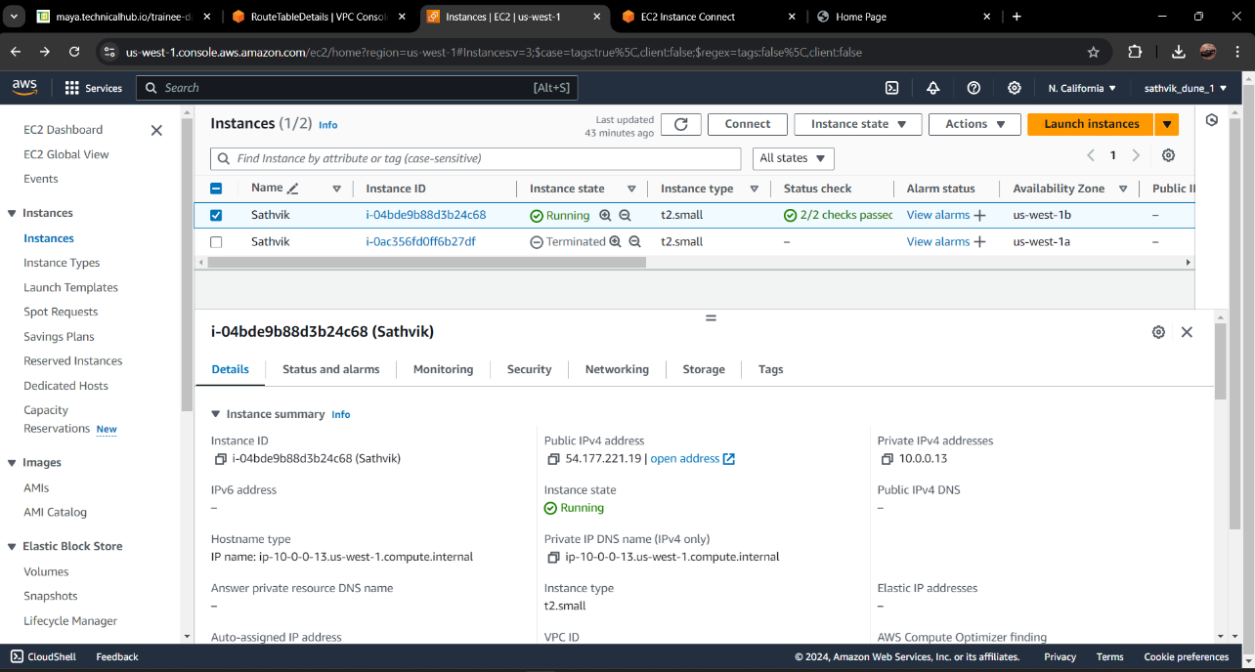

* Through MobaXtearm we connect to linux Server through SSH.

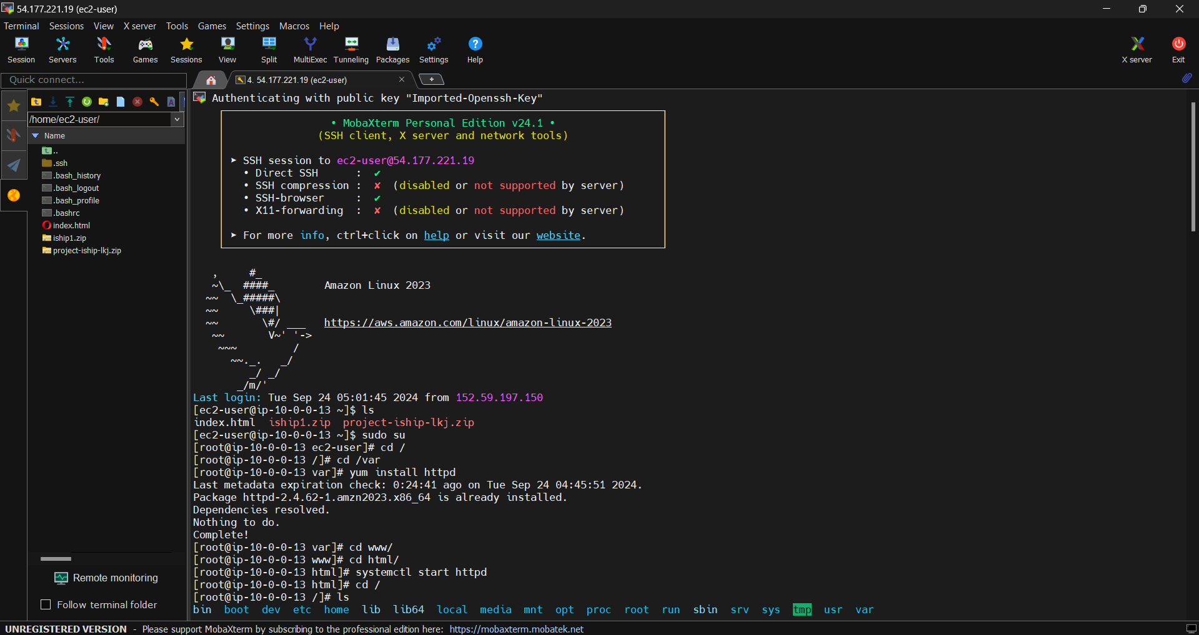

* After connecting the linux go to /var/www/html location

And delete the default the html file.

* Move the ‘vihara yatra’ website files to the /var/www/html location and restart the linux server

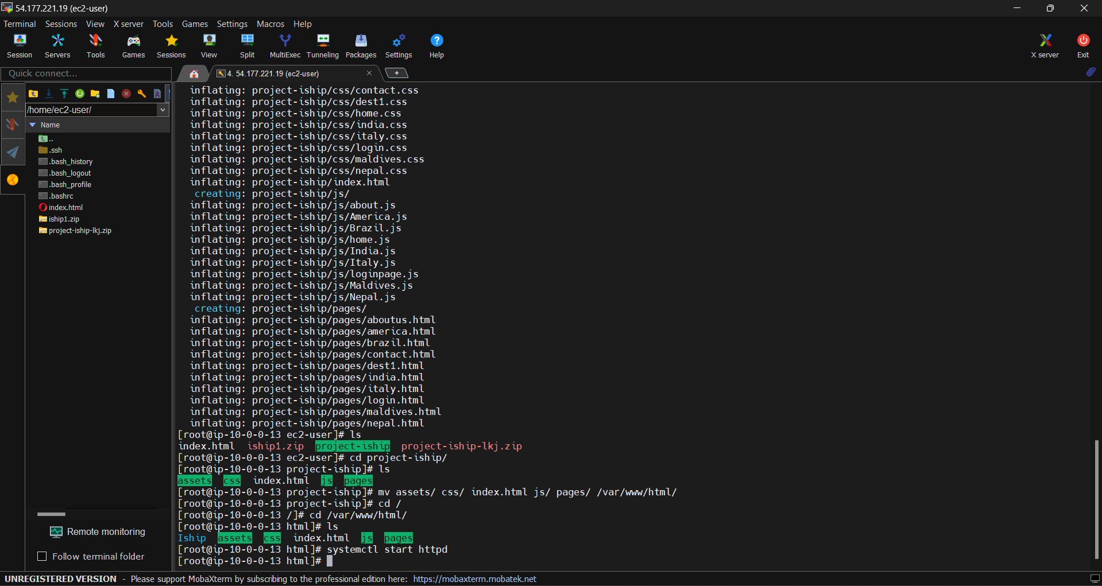

* The EC2 Instance Public Ip Adress Brose on the any of the browser you get the web application page

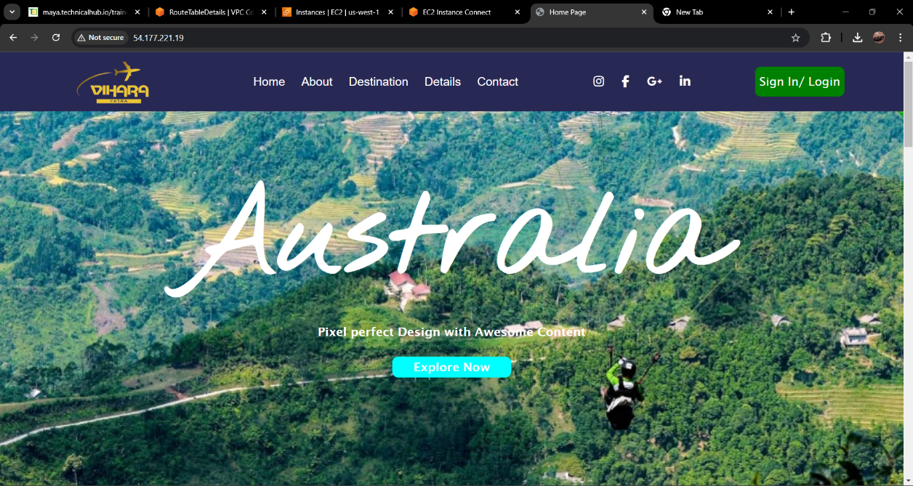

**CHAPTER 6: Outcomes Description**

**Project Outcomes: Hosting an Website VIHARA YATRA on EC2**

1. Infrastructure Setup and Configuration

* Launched and configured an EC2 instance tailored for hosting a dynamic

website.

* Selected appropriate instance types (e.g., t3. medium or higher) for optimal

performance based on projected traffic.

2. Web Server and Application Server Setup

* Installed and configured Apache or Nginx as the web server to handle dynamic

requests.

* Successfully integrated server-side programming environments like PHP, Node.js,

or Python required by the chosen e-commerce platform (Magento, WooCommerce,

etc.).

3. Database Setup and Management

* Set up and configured a database server (MySQL, MariaDB) on the EC2 instance

or using Amazon RDS for scalable database management.

* Ensured secure database connections and configured database backups for disaster

recovery.

4. Platform Deployment

* Installed and deployed a popular mobaxterm platform such as Magento,

, or OpenCart.

* Configured the platform with necessary plugins, themes, and modules to enable e-

commerce functionality (cart, payment gateways, etc.).

5. SSL Encryption and HTTPS Setup

* Successfully implemented SSL certificates using Certbot and Let's Encrypt to

enable HTTPS, securing transactions and protecting user data.

* Ensured compliance with security standards for handling sensitive customer

information.

6. Domain and DNS Configuration

* Assigned an Elastic IP to the EC2 instance for a static IP address.

Configured DNS settings to link a custom domain to the EC2 instance, making the

* e-commerce site accessible via the domain.

7. Performance Optimization

* Enabled caching mechanisms (Memcached, Redis) to improve site speed and

reduce server load.

* Integrated Amazon CloudFront (CDN) to deliver content faster across global

locations, improving website performance.

* Implemented server-side optimization techniques for faster page load times and

user experience improvements.

8. Scalability and Auto Scaling

* Configured Auto Scaling to automatically increase or decrease the number of EC2

instances based on traffic demand, ensuring high availability and performance

under load.

**Student Self Evaluation Of The Short-Term Internship**

**Student Name: DUNE SANKAR NARAYAN SATHVIK**

**Registration No: 22P31A4279**

**Duration of Internship:**

**From:** 16-05-2024 **To:** 15/07/2024

**Date of Evaluation:**

**Organization Name & Address**: Technical Hub Pvt Ltd, Surampalem,533101.

Please rate your performance in the following areas:

**Rating Scale: Letter grade of CGPA calculation to be provided**

|  |  |  |  |  |  |  |
| --- | --- | --- | --- | --- | --- | --- |
| 1 | Oral communication | 1 | 2 | 3 | 4 | 5 |
| 2 | Written communication | 1 | 2 | 3 | 4 | 5 |
| 3 | Interaction ability with community | 1 | 2 | 3 | 4 | 5 |
| 4 | Positive Attitude | 1 | 2 | 3 | 4 | 5 |
| 5 | Self-confidence | 1 | 2 | 3 | 4 | 5 |
| 6 | Ability to learn | 1 | 2 | 3 | 4 | 5 |
| 7 | Work Plan and organization | 1 | 2 | 3 | 4 | 5 |
| 8 | Quality of work done | 1 | 2 | 3 | 4 | 5 |
| 9 | Time Management | 1 | 2 | 3 | 4 | 5 |
| 10 | Achievement of Desired Outcomes | 1 | 2 | 3 | 4 | 5 |
| **OVERALL PERFORMANCE** | |  |  |  |  |  |

Student Signature

**Evaluation By The Supervisor Of The Intern Organization**

**Student Name: DUNE SANKAR NARAYAN SATHVIK**

**Registration No: 22P31A4279**

**Duration of Internship:**

**From: 16-05-2024 To : 15-07-2024**

**Date of Evaluation:**

**Organization Name & Address**: Technical Hub Pvt Ltd, Surampalem,533101

**Name & Address of the Supervisor with Mobile Number**

Please rate the student’s performance in the following areas:

Please note that your evaluation shall be done independent of the Student’s selfevaluation

**Rating Scale: 1 is lowest and 5 is highest rank**

|  |  |  |  |  |  |  |
| --- | --- | --- | --- | --- | --- | --- |
| 1 | Oral communication | 1 | 2 | 3 | 4 | 5 |
| 2 | Written communication | 1 | 2 | 3 | 4 | 5 |
| 3 | Interaction ability with community | 1 | 2 | 3 | 4 | 5 |
| 4 | Positive Attitude | 1 | 2 | 3 | 4 | 5 |
| 5 | Self-confidence | 1 | 2 | 3 | 4 | 5 |
| 6 | Ability to learn | 1 | 2 | 3 | 4 | 5 |
| 7 | Work Plan and organization | 1 | 2 | 3 | 4 | 5 |
| 8 | Quality of work done | 1 | 2 | 3 | 4 | 5 |
| 9 | Time Management | 1 | 2 | 3 | 4 | 5 |
| 10 | Achievement of Desired Outcomes | 1 | 2 | 3 | 4 | 5 |
| **OVERALL PERFORMANCE** | |  |  |  |  |  |

**Signature of the Supervisor**